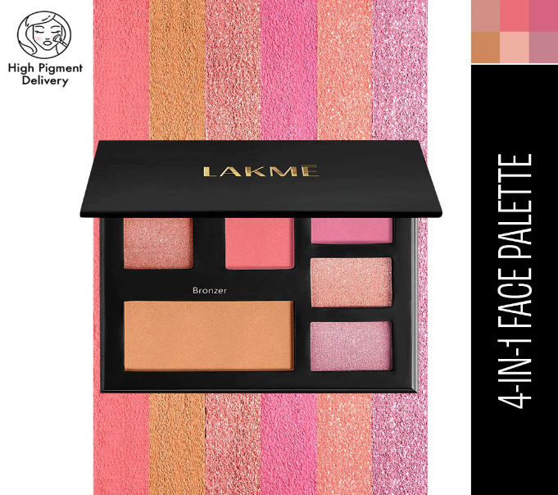 SS

Details

**Free Shipping on Orders over ₹ 750**

Pick shade/s

Day Queen

**Color: Day Queen**

**Try Now**

**₹1,199**

# LAKMĒ GLITTERATI FACE PALETTE

Details

ADD TO DETAIL

1

Add to Wishlist

DETAILS

INFORMATIONS

HOW TO USE

Dff

F